Differential Genes and Proteins

Metabolic Analysis

CC1A3

# Introduction

This document describes the metabolic changes as identified in RNASEQ and proteomics.

In this experiments *Prochlorococcus* MED4 and *Alteromonas* HOT1A3 were grown for 90 days in co-culture and mono-culture controls. The goal of the experiment is to identify the mechanisms sustaining their survival for a long time under nitrogen starvation. For that end, they were grown in a media with low nitrogen (ammonium) concentration. Samples for RNASEQ and proteomics were taken during exponential growth (timepoint 1, ~day 7), decline (timepoint 2, ~day 10) and during long term starvation (timepoint 3, 4, 5 on days 30, 60, 90 respectively).

# *Prochlorococcus* MED4

|  |
| --- |
|  |
| Figure 1: enriched KEGG pathways and modules in *Prochlorococcus* MED4. |

The following KEGG pathways are enriched in *Prochlorococcus* MED4: Membrane transport, Carbohydrates, Energy, Amino acids, Nucleotides, Lipids, Membrane transport, Translation, cofactors and vitamins, terpenoids and polyketides, other secondary metabolites.

## Membrane transport

|  |
| --- |
|  |
| Figure 2: Differentially expressed membrane transport genes and proteins in *Prochlorococcus* MED4. |

Membrane transport and ABC transporters are upregulated in the proteome of the co-culture. This is dominated by transport nitrogen containing compounds (urea and nitrate).

The transport systems for nitrate/nitrite, urea, and energy-coupling factors and the translocation of sec-independent protein are upregulated in the co-culture as well as in the axenic controls (though a few urea transport genes are downregulated in RNASEQ timepoint 3,4 and upregulated in the proteome and the same time).

Transport of iron(III), manganese, and phosphonate, is downregulated while the transport of phosphate and phospholipid/cholesterol/gamma-HCH and the translocation of preprotein is downregulated in the RNA and upregulated in the proteome.

The export of lipopolysaccharide is downregulated, though only 1/2 genes in the system is differentially expressed.

Other DE genes belong to:

ATP-binding cassette, subfamily B, multidrug efflux pump (mdlAB) is upregulated.

Other genes that are not differentiall expressed in coculture (but do change in the axenic contro) include, vitamin B12/bleomycin/antimicrobial peptide , signal recognition particle (ftsY, ffh) and YidC/Oxa1 family membrane protein insertase (yidC).

## Nucleotide metabolism

|  |
| --- |
|  |
|  |

Purine metabolism is upregulated in the later stages of the co-culture proteome, as well as in the later stages of the axenic *Prochlorococcus* MED4.

Of note are:

Upregulating of ureABC, involved on urea degradation

Downregulation of carbamoylphosphate synthase (carAB) involved in multiple pathways (L-glutamine degradation,, glutaminyl-tRNAgln biosynthesis via transamidation, L-asparagine biosynthesis III (tRNA-dependent), pyrimidine ribonucleotides de novo biosynthesis, L-arginine biosynthesis II (acetyl cycle), UMP biosynthesis I, L-arginine biosynthesis I (via L-ornithine), L-citrulline degradation

The genes involved in GO:0006164 - purine nucleotide biosynthetic process (pur*) where the proteome is upregulated, and 3/14 transcripts are down regulated.

Ppgpp genes (spoT, ndk) are not differentially expressed in the co-culture.

## Translation

|  |
| --- |
|  |
|  |

Translation seems to be slowed down under long term starvation. Ribosomal proteins are downregulated in the co-culture proteome as well as in the decline stage of the axenic MED4. tRNA biosynthesis is also downregulated, though not significantly. Conversely, some of these translation proteins are upregulated in the later stages of the axenic proteome.

## Lipid metabolism

|  |
| --- |
|  |
|  |

Lipid metabolism and specifically fatty acid biosynthesis and degradation are downregulated under long term starvation in both the co-culture and the axenic culture.

## Energy metabolism

|  |
| --- |
|  |
|  |
|  |

Nitrogen metabolism is strongly upregulated in all cultures.

Photosynthesis is downregulated in both the co-cultures and axenic cultures.

Carbon fixation, Carbon fixation pathways in prokaryotes, Sulfur metabolism, and Methane metabolism are downregulated in the co-culture, though the enrichment is not significant.

Oxidative phosphorylation results are mixed, genes that also participate in photosynthesis are downregulated while the rest are upregulated.

## Carbohydrate

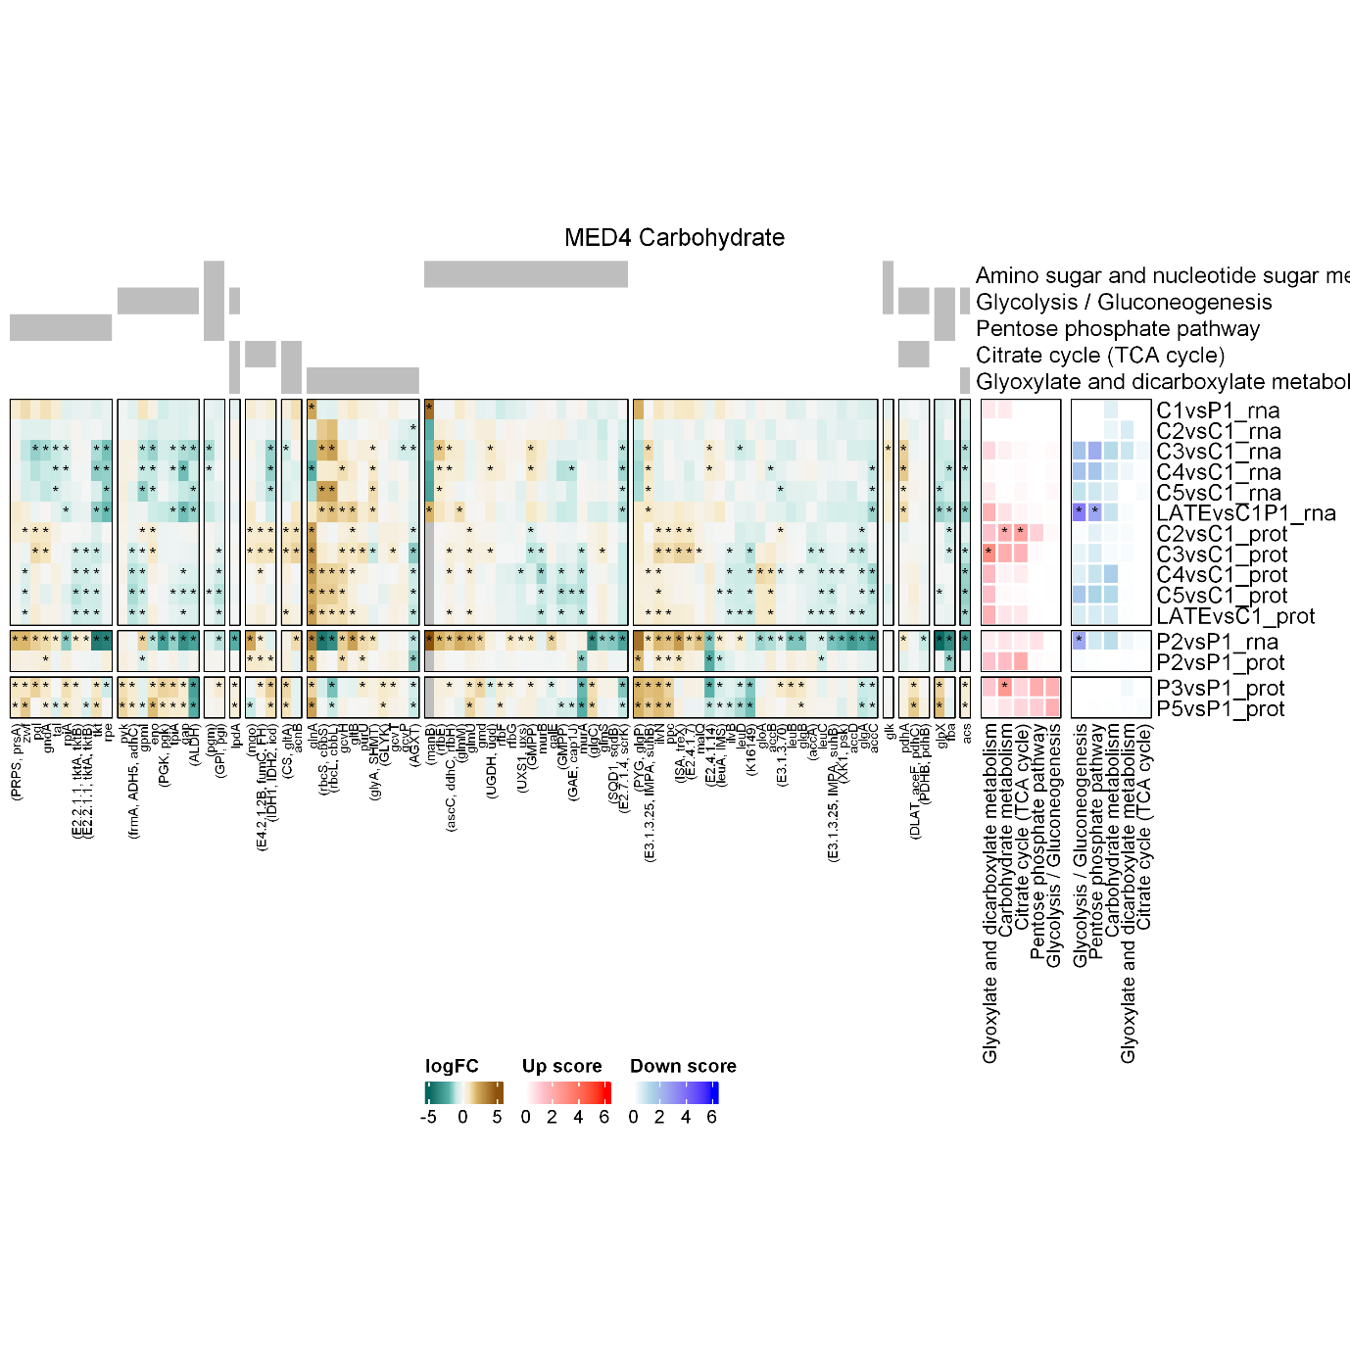

## Amino acids

## Cofactors and vitamins

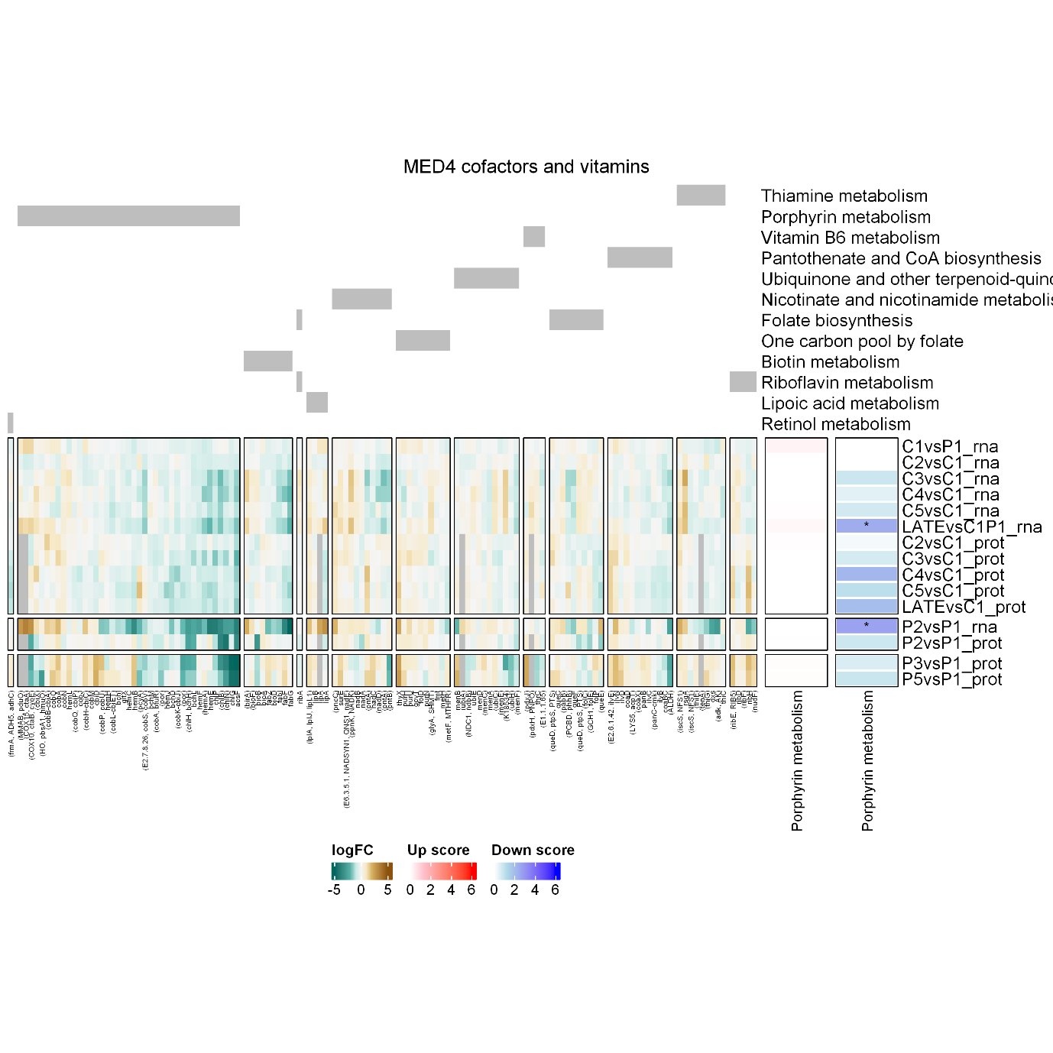

## secondary metabolites

## terpenoids and polyketides

